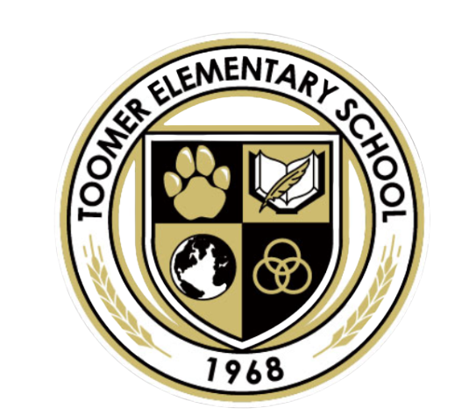
August 13, 2025
Dear Parents and Guardians,
Welcome to a brand-new school year! I am thrilled to partner with you in supporting your child’s growth and success in our Gifted and Talented Program. This year promises to be an exciting journey filled with opportunities for your child to think critically, explore creatively, and engage in meaningful learning experiences that challenge and inspire them.
Our focus in the gifted program is to provide differentiated instruction that meets the unique needs of advanced learners while encouraging curiosity, problem-solving, and collaboration. Students will be participating in activities that foster higher-level thinking, real-world application, and independent inquiry projects that align with both the Georgia Standards of Excellence and the IB philosophy of developing internationally minded learners.
I value strong communication between home and school. Throughout the year, I will share updates, student progress, and opportunities for you to be involved in our program. If you ever have questions or insights about your child’s learning, please do not hesitate to reach out to me. Together, we can ensure your child has a year full of academic growth, personal development, and memorable experiences.
Thank you for entrusting me with the privilege of working with your gifted learner. I look forward to a fantastic year ahead!
Warmly,
Ursula Borland
Gifted Lead Teacher
ursula.borland@atlanta.k12.ga.us

